WEEK 2-footprinting with multiple tools v1
Task 1. Run whois to find the domain registration details.
Query the public domain registration record to find who owns the domain, when it
was registered, and its name
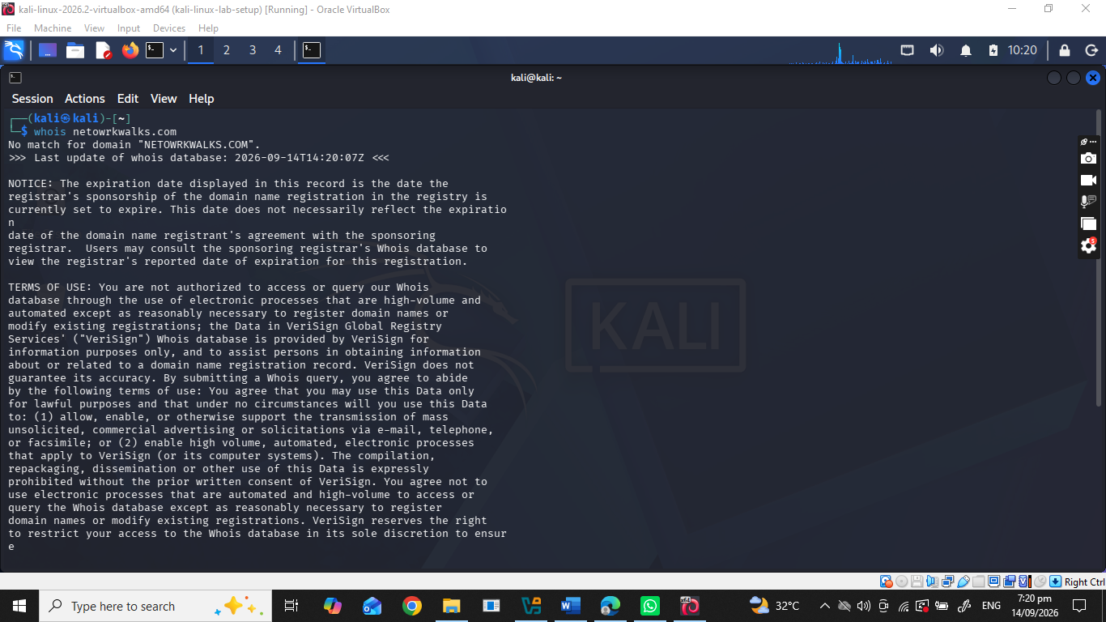
Task 2. Run whatweb to fingerprint the web technologies.
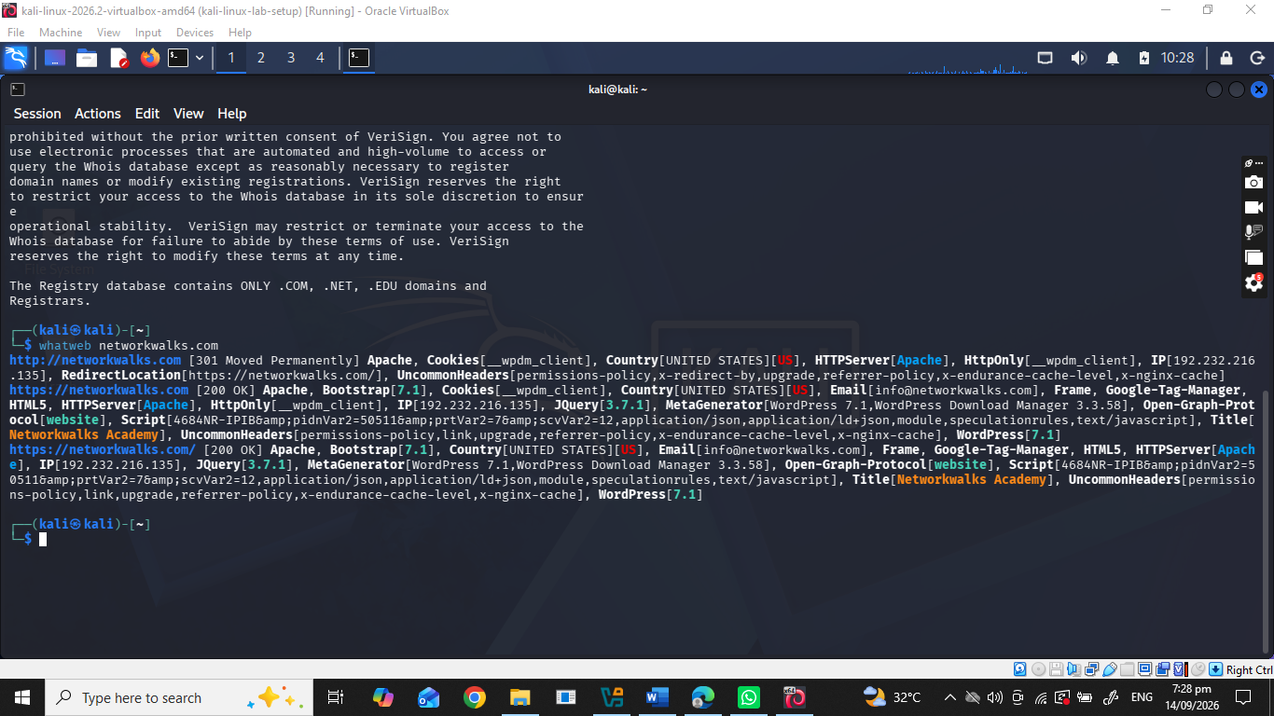
Task 3. Run nslookup to resolve the domain to its IP address.
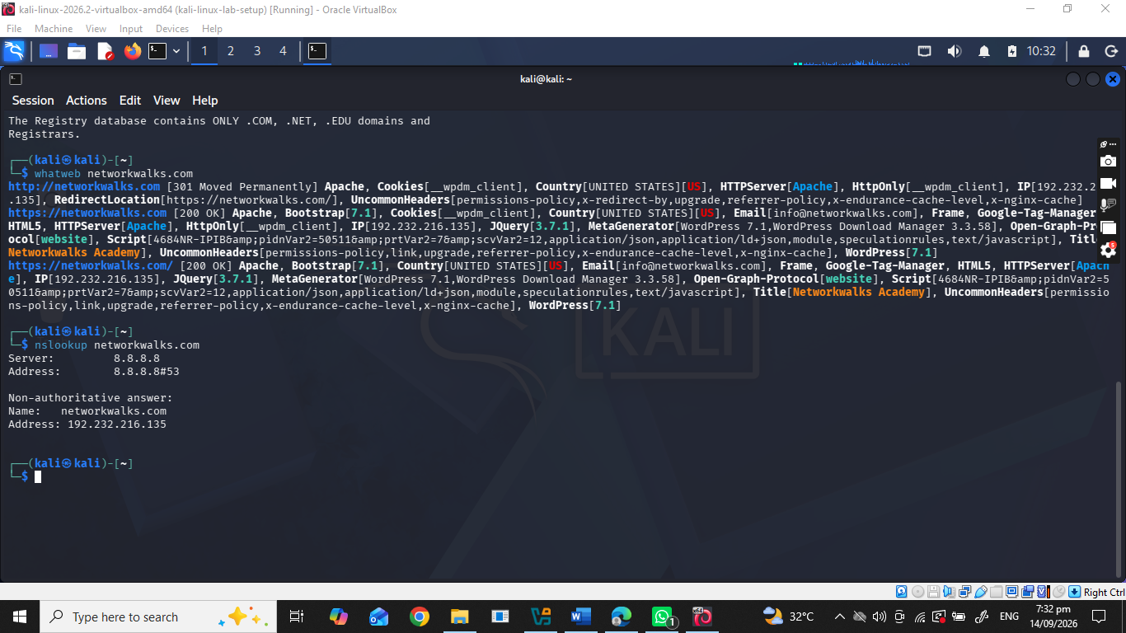
Task 4. Run curl -I to read the HTTP response headers.
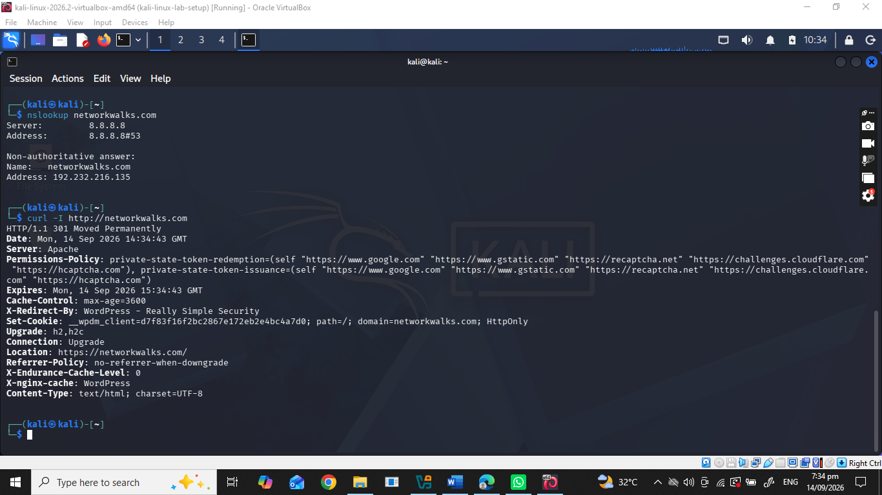
Task 5. Run wafw00f to detect a Web Application Firewall.
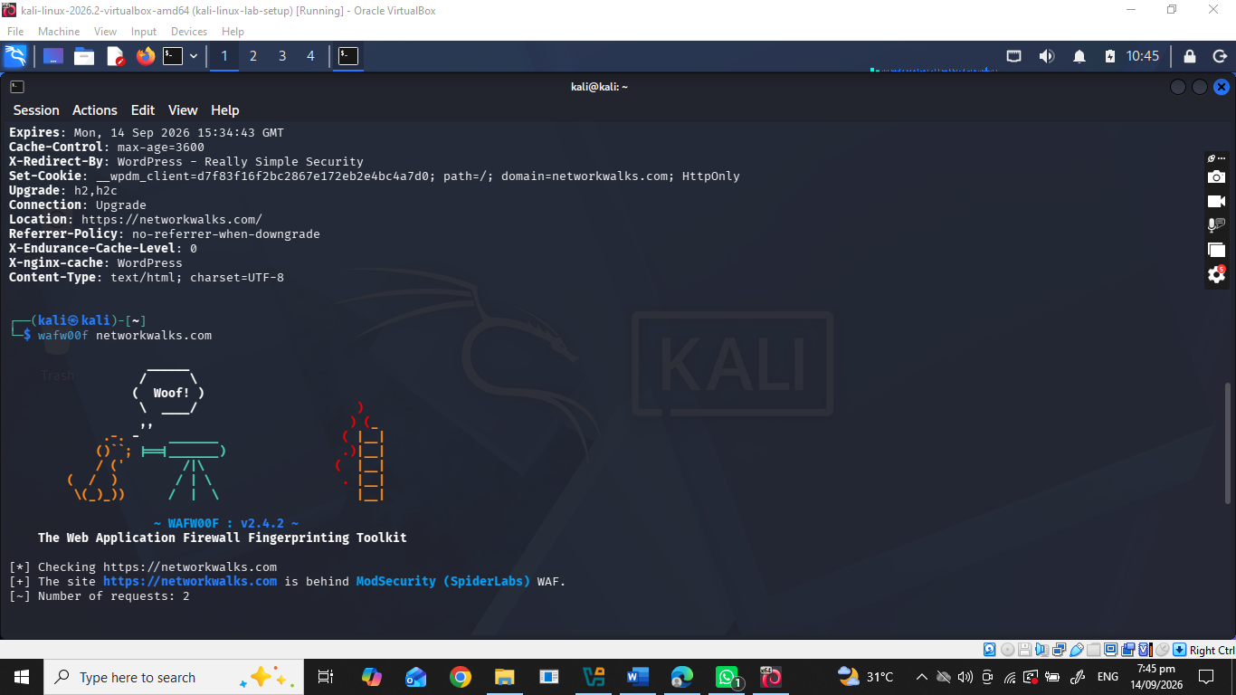
Task 6. Run dnsrecon to enumerate all DNS records.
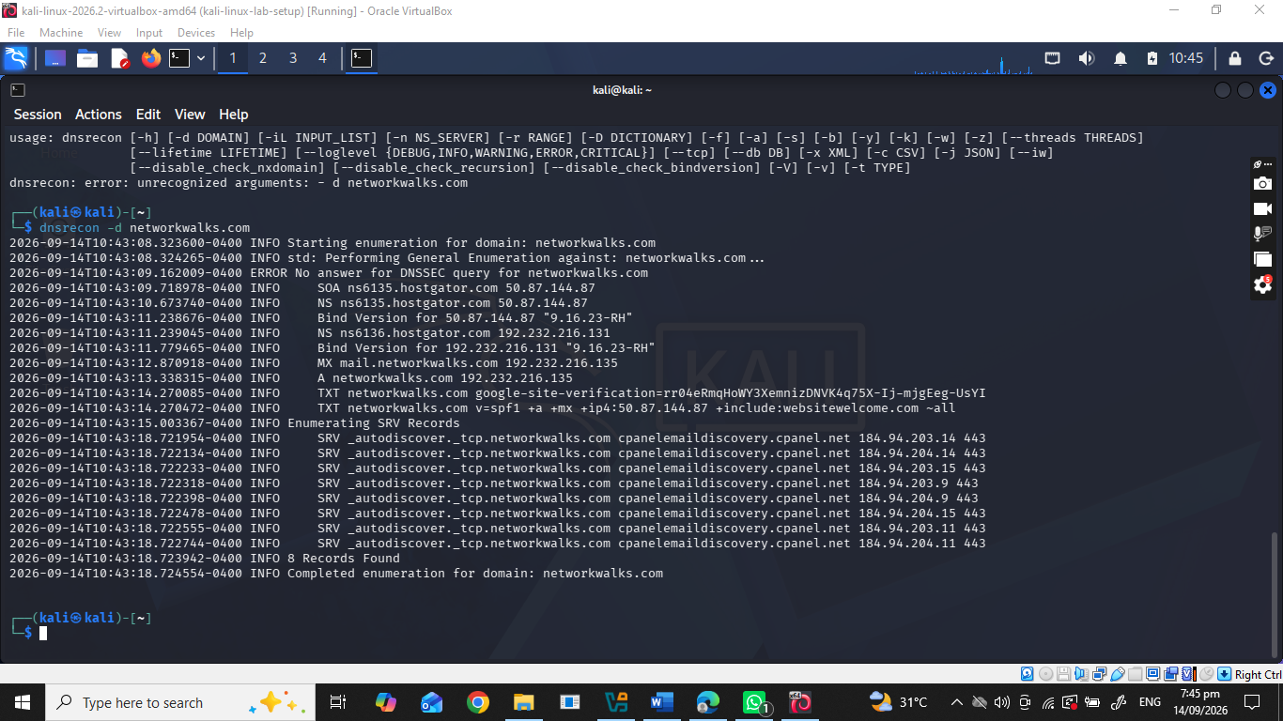
Week 2 PM5-wNetwork scanning with zenamp
Download zenmap
